**SHADE APP Manual**

**Application**

1. Open the “SHADEApp.bat”. If it is the first time you are opening the app, it should start to install any dependencies that are not yet installed. For the succeeding times, it should take you directly to the Application’s Landing page. But do note that the program will still check if you have all the required libraries each time.

Six modular applications will be displayed and you may select which one you wish to use.

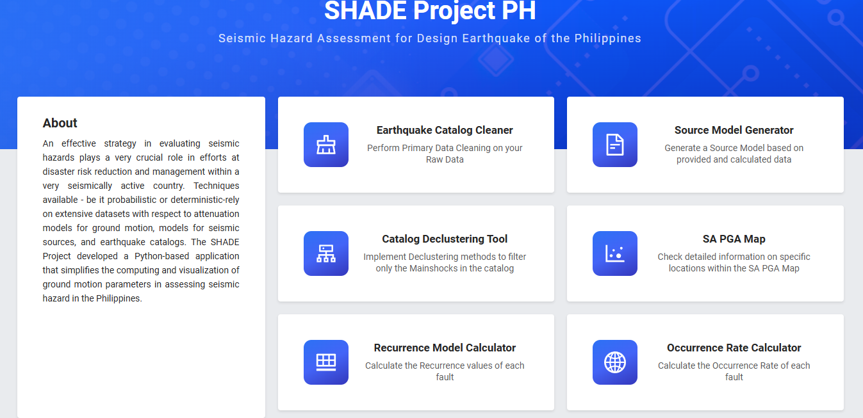

1. To use the module, simply click on the card. This should open the Inputs window.

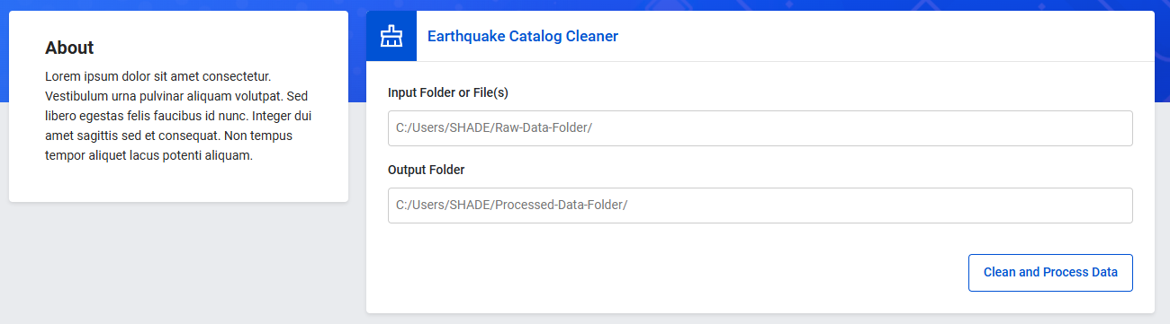

1. To input files. Right-click on the file you wish to input and select “Copy as Path”. Go back to the App and paste the address to its respective text box.

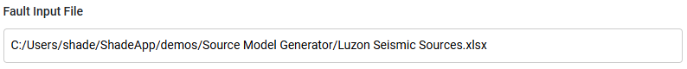

1. Press the button on the bottom right and wait. Once finished, click the Done button and open the windows explorer on the address where the output files are directed to.

**Special Instructions**

1. Some inputs require folders, double check the address. Sample inputs are displayed as placeholders for reference.
2. The input file for the Catalog Declustering tool is a specific file. Open the Aegean_ExtendedCat1.csv template file and paste your EQ Events there.
3. For any Issues/Bugs/Improvements that you can log, please fill up in this form https://docs.google.com/spreadsheets/d/1n6z0CbvbN1qemfDGz1ZVjk_t_4Z_f5QpGb__cxj4S-w/edit?usp=sharing